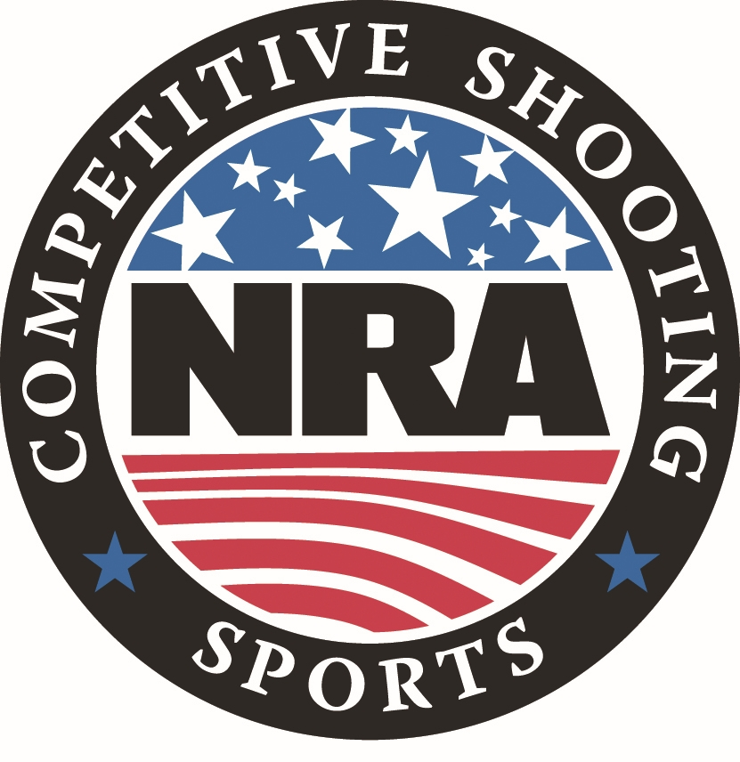**National Rifle Association**

**NATIONAL INDOOR SECTIONAL TOURNAMENT PROGRAM**

**for**

**PRECISION PISTOL**

The NRA Competitive Shooting Division sanctions locally sponsored Indoor Sectional Tournaments around the country each year. Local Sponsors conduct their Tournament during the assigned time frame established by the NRA and follow the applicable NRA Rules and conditions within this Tournament Program. Sectional Tournaments are conducted under the same requirements as Registered Tournaments and as such require turning targets.

Once fired, scores are compiled by the Tournament Statistical Officer and a local Sponsor’s Official Results Bulletin produced. Scores are then sent to the NRA Competitive Shooting Division where all scores from across the country are combined for the NRA National Indoor Sectional Championship. Awards are then issued as outlined in the Awards Schedule.

**National Indoor Sectional Tournament Information & Tournament Conditions**

**Speed Links:**  For your convenience, this Program has numerous Speed Links. If reading this program on-line and you see bolded text in blue, you can click on the blue text and it will automatically take you to the online NRA information page for that section. If you are reading a printed copy of the Program and see a digital Quick Reader Code Box in the right-hand border, use your smart phone camera to hover over the QR Code box as if you were going to take a photo of it. While smart phones vary, your phone camera should automatically scan the QR Code and present a pop-up window for you to tap. When you tap it, the NRA online page for that section will open on your phone.

**National Indoor Sectional Tournament Officials:**

Tournament Director: Cole McCulloch - NRA Competitive Shooting Division Director

Chief Statistical Officer: Donna Webb - NRA Competitive Shooting Division Tournament Operations

Manager

**Tournament Dates:** This year, National Indoor SectionalTournaments must be conducted between January 1st and April 15th, 2025.

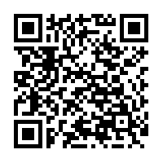**Governing Rules:** Current NRA Precision Pistol Rules will govern. Competitors are responsible to have full knowledge of the Rules under which the match is fired, ensure that

their equipment meets all Rules and match specifications, and comply with any instructions

from a Tournament Official. If a competitor has a question concerning any Rule or

equipment they must bring it to a Tournament Official prior to firing the match involved.

You can find [***NRA Rule Books***](https://competitions.nra.org/competition-resources/rule-books/) online or by using your smart phone camera to scan the Quick Reader Code to the right.

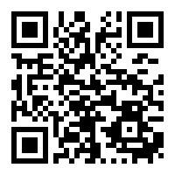**NRA Membership:** NRA Membership is not required but highly encouraged. Membership information is available online by clicking [***HERE***](https://membership.nra.org/recruiters/join/XC030662), or using your smart phone camera to scan

the Quick Reader Code to the right. Tournament Sponsors normally also have membership information.

**Individual Eligibility:** A competitor may enter any NRA Sectional Indoor Tournament individual or team match but may fire in only ONE of this type Sectional Tournament in 2024. Competitors may enter other types of Sectionals if eligible for that Tournament.

**Team Categories:** The Team Match is a **FIRED** Match. Teams will consist of 4 firing members following:

* Rule 2.11 - State Association Team
* Rule 2.15 - Civilian Club Team
* Rule 2.14 - Law Enforcement Agency Team
* Rule 2.13 - Regular Service, National Guard or Reserve Unit Team

Teams composed of competitors not all in the same category are Mixed Teams and not eligible for any National Team Award and will not be included in National Preliminary or Final Result Bulletins. Tournament Sponsors may issue established Mixed Team Awards at the Sectional level.

**Match Conditions:** Since Sectional Scores are to be used to determine National Champions, all

Sectionals must be conducted in the prescribed manner.

All ties will be broken according to the NRA Precision Pistol Rules.

Distance: 50 feet

Equipment: .22 Caliber Pistol = Rule 3.4

NRA Target: B-2 Slow Fire Target

B-3 Timed / Rapid Fire Target

**Matches:**

* **Match 1:** Slow Fire - 20 shots, 2 strings of 10 rounds, 10 minutes per string.
* **Match 2:** Timed Fire - 20 shots, 4 strings of 5 rounds, 20 seconds per 5 shot string.
* **Match 3:** Rapid Fire - 20 shots, 4 strings of 5 rounds, 10 seconds per 5 shot string.
* **Match 4:** 30 shots consisting of 10 rounds Slow Fire, 10 rounds Timed Fire, and 10 rounds Rapid

Fire - Gallery Course.

* **Match 5:** Aggregate of Matches 1 through 4 - 90 shots total.
* **Match 6:** Fired Team Match - NRA Gallery Course. All Team Members must fire.

**Tournament National Match Fees:** Individual Matches $ 8.00 Per Match

Team Matches $ 5.00 Per Team

**Tournament Sponsor Fees:** There may be local Tournament Fees published by the Tournament Sponsor, such as a Club Fee or Range Maintenance Fee.

**Registration**: Individual match entry must be received by the Sponsor of the Tournament you want to register for no later than the Monday preceding the opening date of the Sectional Tournament following the registration process established by the Tournament Sponsor. Team entries may be made any time prior to the start of the firing of the team match. Tournament capacity is determined by each individual Tournament Sponsor.

**Squadding:** Matches will be squadded and assignments made by the Statistical Office. Teams are not required to be squadded to fire as a unit.

**Classification:** Competitors will be entered using their current NRA Classification.

Competitors with expired Classifications and new shooters with no Classification or those without a Temporary Record Score Book will fire in the Master Class as required by Rule 19.6. If a Temporary Score Record Book is used for an Unclassified competitor, the Statistical Officer will document this when the score is sent to the NRA. If the NRA is not notified the shooter will be changed to Master Class for the purposes of the National Aggregate Official Final Results Bulletin.

Rule 19.12 will determine Team Classifications.

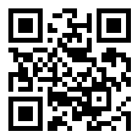

**Classification Lookup:** Competitors may check their current NRA Classification by

going to the [***NRA Competitive Shooting Web Portal***](https://competitor.nra.org/).

**Categories:** Competitors will be divided into three categories per Section 2 of the

NRA Precision Pistol Rules:

* Civilian - Rule 2.2
* Police - Rule 2.4
* Service - Rules 2.5, 2.6, & 2.7
* Competitors will be placed in the Civilian category if a category is not indicated on the Scorecard.

**Special Categories:** Although not required, Tournament Sponsors are encouraged to provide an award for the Highest Scoring Senior, Junior and Woman in the aggregate Match 5.

**Scorecards:** Sectional score cards will be used and must be signed by the competitor to be considered for National ranking and awards. Competitors will be placed in the Civilian Category if a Category is not indicated on the scorecard.

**Score Reporting:** To be entered in the National Aggregate Indoor Sectional Tournament and included in the National Official Final Results Bulletin all scores must be submitted by the Tournament Sponsor to the NRA Competitive Shooting Division by April 22nd, 2025. Any scores received past this date without prior approval will not be processed.

***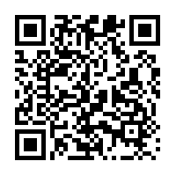*Preliminary & Final Bulletins**: Sectional Tournament Sponsors are responsible for competitors having access to Preliminary and Official Final Bulletins.

NRA National Aggregate Indoor Sectional Championship Preliminary and Official Final

Bulletins will be posted online at the NRA Competitive Shooting Division’s [***National Championship Results***](https://competitions.nra.org/results-and-records/national-matches-results/nra-national-indoor-rifle-pistol-championship-results/)page***.***

**Retention of Targets:** All fired targets must be retained until the National Challenge Period has ended and the 2025 NRA National Indoor Precision Pistol Sectional Final Results Bulletin has been posted online.

**Challenges & Protest:** Challenges and Protests are handled following NRA Rule Book Section 16. When a competitor feels that a shot fired has been improperly evaluated or scored, the scoring may be Challenged. A minimum Challenge Fee of $1.00 with a maximum fee of $3.00 may be charged to all competitors making a Challenge. The fee will be collected before making the first recheck of the Challenged Score. If the competitor’s Challenge is sustained at any point along the line of rechecks, the Challenge Fee will be returned. The decision of the Official Referee, Jury or Supervisor will be final.

**Sectional Awards Schedule**

**Indoor Sectional Tournament Level NRA Awards:** The NRA will provide the following Sectional Awards based on the Tournament Sponsor’s Official Final Results Bulletin. Tournament Sponsors may furnish additional Awards and/or Prizes and set their own separate Awards Schedule for their matches including the Highest Scoring Senior, Junior and Woman in aggregate Match 5 and Team Match 6.

**Match 5: Precision Pistol Indoor Sectional Aggregate Match**

First Place: NRA Gold Tone Sectional Medallion

Second Place: NRA Silver Tone Sectional Medallion

Third Place: NRA Bronze Tone Sectional Medallion

**National Awards Schedule**

**NRA National Indoor Sectional Championship Awards:** The NRA will provide the following NRA National Awards based on the aggregate of all Indoor Sectional competitors participating in the National Indoor Sectional Championships.

**Match 5: National Precision Pistol Indoor Sectional Championship**

First Place: NRA Champion Gold Tone Medal

Norman R. Adair Trophy Plaque

Second Place: NRA National Champion Silver Tone Medal

Third Place: NRA National Champion Bronze Tone Medal

**High Categories:** High Civilian, Police, and Service: NRA Gold Tone Medal

**High Special Categories:**

High Scoring Woman Competitor: NRA Gold Tone Medal

High Scoring Junior Competitor: NRA Gold Tone Medal

High Scoring Senior Competitor: NRA Gold Tone Medal

High Scoring Grand Senior Competitor: NRA Gold Tone Medal

**Class Awards:** Awards will be given in all Classes.

First Place by Class: Gold Tone Medal

Second Place by Class: Silver Tone Medal

Third Place by Class: Bronze Tone Medal

Fourth Place by Class: Bronze Tone Medal

Fifth Place by Class: Bronze Tone Medal

**Match 6: National Precision Pistol Indoor Sectional Team Championship**

First Place Team: NRA Champion Gold Tone Medal

Second Place Team: NRA Champion Silver Tone Medal

Third Place Team: NRA Champion Bronze Tone Medal