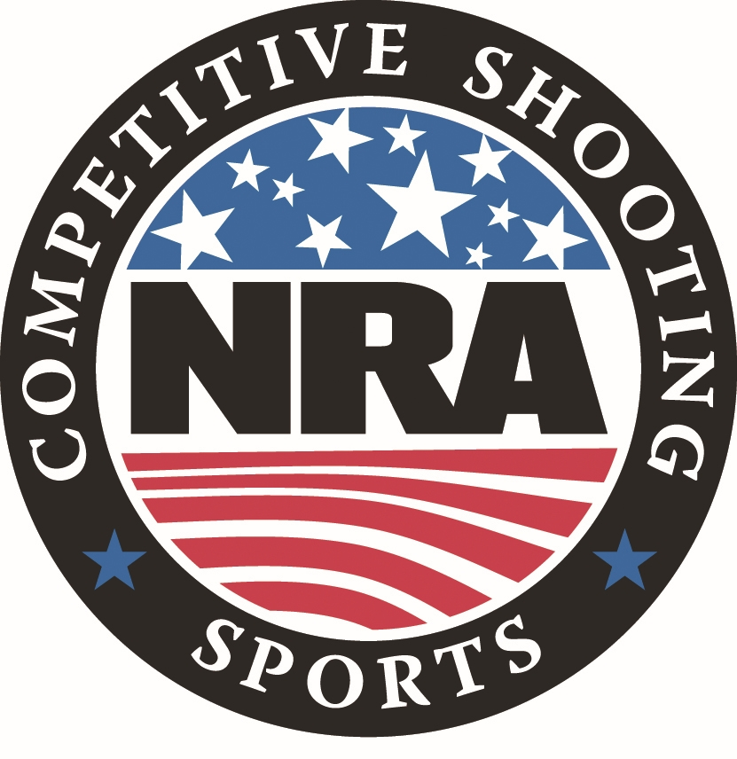**National Rifle Association**

**NATIONAL INDOOR SECTIONAL TOURNAMENT PROGRAM**

**for**

**INTERNATIONAL FREE & STANDARD PISTOL**

The NRA Competitive Shooting Division sanctions locally sponsored Indoor Sectional Tournaments around the country each year. Local Sponsors conduct their Tournament during the assigned time frame established by the NRA and follow the applicable NRA Rules and conditions within this Tournament Program. Sectional Tournaments are conducted under the same requirements as Registered Tournaments.

Once fired, scores are compiled by the Tournament Statistical Officer and a local Sponsor’s Official Results Bulletin produced. Scores are then sent to the NRA Competitive Shooting Division where all scores from across the country are combined for the National Indoor Sectional Championship. Awards are then issued as outlined in the Awards Section.

**National Indoor Sectional Tournament Information & Tournament Conditions**

**Speed Links:**  For your convenience, this Program has numerous Speed Links. If reading this program on-line and you see bolded text in blue, you can click on the blue text it will automatically take you to the online NRA information page for that section. If you are reading a printed copy of the Program and see a digital Quick Reader Code Box in the right-hand border, use your smart phone camera to hover over the QR Code box as if you were going to take a photo of it. While smart phones vary, your phone camera should automatically scan the QR Code and present a pop-up window for you to tap. When you tap it, the NRA online page for that section will open on your phone.

**National Indoor Sectional Tournament Officials:**

Tournament Director: Cole McCulloch - NRA Competitive Shooting Division Director

Chief Statistical Officer: Donna Webb - NRA Competitive Shooting Division Tournament

Operations Manager

**Tournament Dates:** This year, National Indoor SectionalTournaments must be conducted between January 1st and April 15th, 2025.

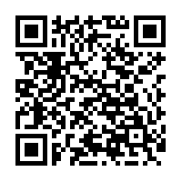**Governing Rules:** Current NRA International Style Pistol Rules will govern. Competitors are responsible to have full knowledge of the Rules under which the match is fired, ensure that

their equipment meets all Rules and match specifications, and comply with any instructions

from a Tournament Official. If a competitor has a question concerning any Rule or

equipment they must bring it to a Tournament Official prior to firing the match involved.

You can find [***NRA Rule Books***](https://competitions.nra.org/competition-resources/rule-books/) online or by using your smart phone camera to scan the Quick Reader Code to the right.

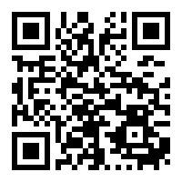**NRA Membership:** NRA Membership is not required but highly encouraged. Membership information is available online by clicking [***HERE***](https://membership.nra.org/recruiters/join/XC030662), or using your smart phone camera to scan

the Quick Reader Code to the right. Tournament Sponsors normally also have membership information.

**Individual Eligibility:** A competitor may enter any NRA Sectional Indoor Tournament individual or team match but may fire in only ONE of this type Sectional tournament in 2025. Competitors may enter other types of Sectionals if eligible for that Tournament.

A Non-US competitor is eligible to participate in NRA Indoor Sectional Tournaments, however only U.S. Citizens may win the First, Second and Third place National Individual and Team Championship awards.

**Team Eligibility:** Team Matches are Unfired and use each Team Members Individual Score from the appropriate match.

Teams will consist of 3 firing members: NRA (Rule 2.11) (A), (B), a Regular Service Unit, National Guard, or Reserves (Rule 2.13), or a State Association (Rule 2.12).

Teams composed of competitors not all in the same category are Mixed Teams and are not eligible for NRA National Aggregate Indoor Sectional Championship NRA Awards.

**Match Conditions:** Since Sectional Scores are to be used to determine National Champions, all

Sectionals must be conducted in the prescribed manner.

Score Cards: Special individual score cards will be used and must be signed by the competitor to be considered for National Ranking. All information must be filled in or scores will not be recorded.

No added matches or practice firing are to be permitted prior to the matches.

All ties will be broken according to the NRA International Pistol Rules with Rule 15.4(d) in lieu of a shoot-off as described in Rule 15.4(c).

Position: NRA International Pistol Rules, Section 5.

After record targets for a relay have been properly mounted, a 10 minute preparation period will be given before the "Commence Firing" command.

Distance: 50 feet

Pistol: Free Pistol = Rule 3.6 Standard Pistol = Rule 3.5

Target: NRA Official 50 foot targets

Free Pistol = B-11

Standard Pistol = B-33

**Matches Offered:**

* **Match 1: International Free Pistol Indoor Sectional Match**

Sixty shots standing, slow fire on the B-11 target.

Total time will be 2 hours for 60 record shots.

Record targets will be consecutively numbered for each competitor and fired in order.

Unlimited sighters may be taken before the match following Rule 7.4.

* **Match 2: International Standard Pistol Indoor Sectional Match**

Slow Fire Stage: 20 shots in 4 series of 5 shots each; 150 seconds per 5 shot series.

Timed Fire Stage: 20 shots in 4 series of 5 shots each; 20 seconds per 5 shot series.

Rapid Fire Stage: 20 shots in 4 series of 5 shots each; 10 seconds per 5 shot series.

There will be separate commands for each five shot series following Rule 7.3.

Sighting Shots: Before the competition begins, a series of five (5) sighting shots may be fired within a time limit of 150 seconds. A sighting target will be provided and clearly marked in order to avoid shots being fired on a record target.

* **Match 3: International Free Pistol Indoor Sectional Team Match**

This is an Unfired Match. The individual scores of each Team Members Match 1 will be used for the Teams Aggregate Score.

* **Match 4: International Standard Pistol Indoor Sectional Team Match**

This is an Unfired Match. The individual scores of each Team Members Match 2 will be used for the Teams Aggregate Score.

**Tournament National Match Fees:** Match 1: $ 8.00

Match 2: $ 8.00

Match 3: $ 5.00 Per Team

Match 4: $ 5.00 Per Team

**Tournament Sponsor Fees:** There may be local Tournament Fees published by the Tournament Sponsor, such as a Club Fee or Range Maintenance Fee.

**Registration**: Individual match entry must be received by the Sponsor of the Tournament you want to register for no later than the Monday preceding the opening date of the Sectional Tournament following the registration process established by the Tournament Sponsor. Team entries may be made any time prior to the start of the firing of the team match. Match capacity is determined by each individual Tournament Sponsor.

**Squadding:** Tournament Sponsors will provide squadding information as necessary. Teams are not required to be squadded to fire as a unit.

**Classification:** Competitors will be entered using their current NRA International Classification.

Competitors with expired Classifications and new shooters with no Classification or those without a Temporary Record Score Book will fire in the Master Class as required by Rule 19.6. If a Temporary Score Record Book is used for an unclassified competitor, the Statistical Officer will document this when the score is sent to the NRA. If the NRA is not notified the shooter will be changed to Master Class for the purposes of the National Aggregate Official Final Results Bulletin.

Team Classifications will be determined by Rule 19.12.

**Classification Lookup:** Competitors and **match directors** may check

current NRA Classification by going to the [***NRA Competitive Shooting Web Portal***](https://competitor.nra.org/).

**Categories:** For Awards purposes in the NRA National Indoor Sectional Championship the following individual Categories will be used:

* High Scoring Woman Competitor
* High Scoring Junior Competitor
* High Scoring Senior Competitor
* High Scoring Grand Senior Competitor

Tournament Sponsors may add their own Category Awards.

**Score Reporting:** To be entered in the National Aggregate Indoor Sectional Tournament and included in the National Official Final Results Bulletin all scores must be submitted by the Tournament Sponsor to the NRA Competitive Shooting Division by April 22nd, 2025. Any scores received past this date without prior approval will not be processed.

***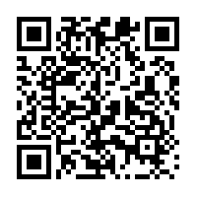*Preliminary & Final Bulletins**: Sectional Tournament Sponsors are responsible for competitors having access to Preliminary and Official Final Bulletins.

NRA National Aggregate Indoor Sectional Championship Preliminary and Official Final

Bulletins will be posted online at the NRA Competitive Shooting Division’s [***National Championship Results***](https://competitions.nra.org/results-and-records/national-matches-results/)page***.***

**Retention of Targets:** All fired targets must be retained until the National Challenge Period has ended as posted by the NRA in the National Preliminary Results Bulletin.

**Challenges & Protest:** Challenges and Protests are handled following NRA Rule Book Section 16.

When a competitor feels that a shot fired has been improperly evaluated or scored, the scoring may be Challenged. A minimum Challenge Fee of $1.00 with a maximum fee of $3.00 may be charged to all competitors making a Challenge. The fee will be collected before making the first recheck of the Challenged Score. If the competitor’s Challenge is sustained at any point along the line of rechecks, the Challenge Fee will be returned. The decision of the Official Referee, Jury or Supervisor will be final.

**Sectional Awards Schedule**

**Indoor Sectional Tournament Level NRA Awards:** The NRA will provide the following Sectional Awards based on the Tournament Sponsor’s Official Final Results Bulletin. Tournament Sponsors may furnish additional Awards and/or Prizes and set their own separate Awards Schedule for all matches.

**Match 1: International Free Pistol Indoor Sectional Match**

First Place: NRA Gold Tone Sectional Medallion

Second Place: NRA Silver Tone Sectional Medallion

Third Place: NRA Bronze Tone Sectional Medallion

**Match 2: International Standard Pistol Indoor Sectional Match**

First Place: NRA Gold Tone Sectional Medallion

Second Place: NRA Silver Tone Sectional Medallion

Third Place: NRA Bronze Tone Sectional Medallion

**National Aggregate Awards Schedule**

**NRA National Indoor Sectional Championship NRA Awards:** The NRA will provide the following NRA National Awards based on the aggregate of all Indoor Sectional Scores participating in the National Indoor Sectional Championships.

**Match 1: International Free Pistol Indoor Sectional Championship**

First Place: NRA Champion Gold Tone Medallion

Viking Trophy Plaque

Second Place: NRA National Champion Silver Tone Medallion

Third Place: NRA National Champion Bronze Tone Medallion

High Scoring Woman Competitor: NRA Gold Tone Medallion

High Scoring Junior Competitor: NRA Gold Tone Medallion

High Scoring Senior Competitor: NRA Gold Tone Medallion

High Scoring Grand Senior Competitor: NRA Gold Tone Medallion

**Match 2: International Standard Pistol Indoor Sectional Championship**

First Place: NRA Champion Gold Tone Medal

Second Place: NRA National Champion Silver Tone Medal

Third Place: NRA National Champion Bronze Tone Medal

High Scoring Woman Competitor: NRA Gold Tone Medallion

High Scoring Junior Competitor: NRA Gold Tone Medallion

High Scoring Senior Competitor: NRA Gold Tone Medallion

High Scoring Grand Senior Competitor: NRA Gold Tone Medallion

**Match 3: International Free Pistol Indoor Sectional Team Match**

First Place Team: Three NRA National Champion Gold Tone Medals

Second Place Team: Three NRA National Champion Silver Tone Medals

Third Place Team: Three NRA National Champion Bronze Tone Medals

**Match 4: International Standard Pistol Indoor Sectional Team Match**

First Place Team: Three NRA National Champion Gold Tone Medals

Second Place Team: Three NRA National Champion Silver Tone Medals

Third Place Team: Three NRA National Champion Bronze Tone Medals